２.孔子故里”文化考察及“我眼中的中国”摄影、写作比赛

2.1申报书

河北经贸大学国际教育学院来华留学生教学活动
申 报 书

项 目 名 称：“孔子故里”文化考察及“我眼中的中国”摄影、
写作比赛
项目主持人： 刘昕远
所 在 学 院： 人文学院
联 系 电 话： 13363810812
电 子 信 箱： 303533651@qq.com
填 表 日 期： 2015年4月6日

国际教育学院制

填 表 说 明

1．填写此表时，不得减少栏目，内容应论述充分。填报内容较多时，请保持整页调整。
2．《申报书》宋体填写，一式四份，使用A4纸打印，左侧装订。
3．所有申请者签名处，不得用打印字和印刷体代替。
5. 项目组不超过4人（含课题负责人）。
一、简表
项目简况 | 项目名称 |  | “孔子故里”文化考察及“我眼中的中国”摄影、写作比赛
项目简况 | 申请经费 |  | 15000元 |  | 拟开展项目时间 |  |  |  | 2015年5月
项  目  主  持  人 | 申请人姓名 |  | 刘昕远 | 性别 | 女 |  | 出生年月 |  | 1971.7
项  目  主  持  人 | 申请人职务及职称 |  | 讲师
项  目  主  持  人 | 教  学  工  作  简  历 | 时 间 | 课 程 名 称 |  |  | 授课对象 |  | 学时 |  | 所 在 单 位
项  目  主  持  人 | 教  学  工  作  简  历 | 2004年9月至今 | 《对外汉语教学法》 |  |  | 对外语  专业  学生 |  | 每学期51 |  | 人文学院
项  目  主  持  人 | 教  学  工  作  简  历 | 2004年9月至今 | 《对外汉语教学概论》 |  |  | 对外汉语专业学生 |  | 每学期51 |  | 人文学院
项  目  主  持  人 | 教  学  工  作  简  历 | 2008-2010 | 初级汉语综合课 |  |  | 孔子学院学生 |  | 每学期357 |  | 加德满都大学  孔子学院
项  目  主  持  人 | 教  学  工  作  简  历 | 2010年  至今 | 《中级汉语 桥梁》 |  |  | 留学生  语言生 |  | 每学期102 |  | 人文学院
项  目  主  持  人 | 教  学  工  作  简  历 | 2013年  至今 | 《HSK辅导》 |  |  | 留学生  语言生 |  | 每学期68 |  | 人文学院
成  员  ︵不含负责人︶ | 姓名 | 出生年月 | 专业技术职务及最终学历 |  |  |  |  | 项目中的分工
成  员  ︵不含负责人︶ | 董葆莉 | 1970.6 | 讲师 硕士研究生 |  |  |  |  | 文化讲解，协助组织活动
成  员  ︵不含负责人︶ | 安兰朋 | 1976.8 | 讲师 博士研究生 |  |  |  |  | 文化讲解，协助组织活动
二、立项背景与意义
1．项目描述

本项目基于本学期的具体情况，主要面向在我校读硕士的留学生开展文化考察及摄影比赛，活动包含以下三个项目：
- “孔子故里”文化考察活动
“孔子故里”山东曲阜被称为“东方圣城”，是中国伟大的教育家、政治家、思想家，世界最著名的文化名人之一孔子的故乡，也是东方文化的重要发祥地和世界历史上最古老、最伟大的文化胜地之一。通过对曲阜的文化考察，可以使留学生更深入地了解中国文化，调动留学生的学习热情和爱华情怀。
- 留学生“我眼中的中国”摄影比赛
摄影比赛是基于文化考察活动而开展的，要求留学生在文化考察活动中把最能体现中国特色的一面用相机记录下来，考察回来后举办摄影比赛。要求参赛照片要有时间、地点、照片说明等说明性文字。通过照片，展示留学生眼中不一样的中国，加强留学生对中国的认识和了解，我们也可以通过照片来了解学生的所思所想。
- 留学生“我眼中的中国”写作比赛
本项目要求留学生把文化考察的体会和感受写下来，根据汉语水平，可以选择用中文或英文写作，鼓励用中文写作。考察回来后，一星期内完成上交作文，将进行作文评比。

2．本选题的意义和价值

为了更好地服务和管理留学生，培养“知华、友华”的留学生，我们在提高教学质量，抓好服务，严格管理之外，还应该开展丰富多彩的课外活动。
“孔子故里”山东曲阜被称为“东方圣城”，是中国伟大的教育家、政治家、思想家，世界最著名的文化名人之一孔子的故乡，也是东方文化的重要发祥地和世界历史上最古老、最伟大的文化胜地之一。通过对曲阜的文化考察，可以使留学生更深入地了解中国文化，调动留学生的学习热情和爱华情怀。
“我眼中的中国”摄影比赛对学生的专业、汉语水平没有限制和要求，能够调动学生参与的积极性，引导他们观察中国、了解中国。而写作比赛能更好地督促学生认真观察和思考，并用汉语表达自己的思想，能够提高学生的汉语写作水平。
留学生课外活动是留学生教育的重要组成部分，是课堂教学的有益补充。搞好留学生课外活动，可以帮助留学生理解、消化课堂上所学的内容，可以促进中外文化交流，促使留学生新文化观的形成。通过组织开展留学生课外活动，可以增加留学生与对外汉语教师及管理人员的交流与接触，增进彼此的信任感，也有利于管理者了解学生的思想状况。这对于稳定留学生思想，消除不稳定因素具有积极的作用。

三、项目实施方案
1．项目具体方案

（1）2015年5月 “孔子故里”文化考察
组织我校在读硕士留学生赴曲阜进行文化考察，为期两天。第一天，在曲阜游览考察孔府、孔庙、孔林，老师负责讲解文化知识，结束后赴泰安。第二天考察中国“五岳之首”、象征中华之魂的泰山，欣赏美丽风景和名人书法，感悟泰山文化。（可以参加旅行社）
（2）文化考察回来后，举办留学生“我眼中的中国”摄影、写作比赛。
文化考察前布置任务，发布比赛消息，要求参加文化考察的学生必须参赛，参赛照片要有时间、地点、照片说明等说明性文字。写作比赛鼓励用中文写，考察回来一周内上交，进行评比。

2．项目拟达到的目标
（1）增进留学生对中国文化和国情的了解。
（2）提高留学生汉语水平。
（3）增进师生彼此了解。

3．拟解决的关键问题
留学生大部分时间封闭在校园里，对中国的国情和文化了解不够，他们眼中的中国和中国文化是片面甚至错误的。通过文化考察活动及相关的摄影比赛，开阔学生的视野，增强他们对中国文化和国情的了解，培养“知华、友华”的留学生。

4．本项目的特色及创新性

（1）特色

在中国，最能代表中国文化的历史名人当数孔子，了解中国文化，就要走进东方文化的重要发祥地、具有“东方圣城”美誉的山东曲阜。该项目引导留学生走出校园，走进中国文化圣地，并举办相关的摄影比赛，具有一定的特色。

（2）创新点
该项目的创新点在于把文化考察和摄影、写作比赛巧妙地结合在一起，引导留学生带着问题和思考进行文化考察，更利于达到文化考察的目的。

四、经费预算
支出项目 | 金额（元） | 依 据 及 理 由
资料费
交通费
活动费
其 它
合 计
五、评审意见
（盖 章）
20 年 月 日

2.2学生作品
SCHOOL TRIP’S REPORT
By HO YEW SANG Safy Syndie.
In this paper, we will talk about Shandong culture and also a brief summary of our school trip in Tai’an city.
- About Tai’an
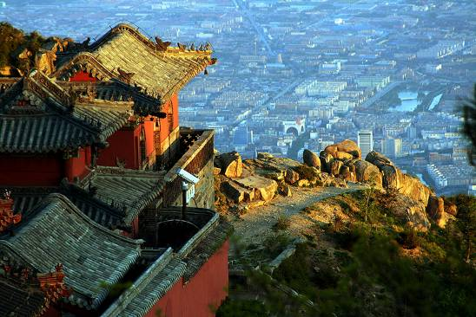
Tai’an is an open tourism city in Eastern China. It is located at the southern side of Mount Tai and in the middle of Shandong Province. It neighbors Laiwu, Zibo and Linyi in the east and connects Jining in the south and faces Liaocheng and Puyang of Henan Province across the Huanghe River in the west. It covers an area of 7762 square kilometers with the population of 5.5887 million and governs 6 districts, counties, and county-level cities: Taishan District, Daiyue District, Xintai City, Feicheng City, Ningyang County and Dongping County.
Tai’an is one of cradles of Chinese Civilization. The existence and development of human beings here dates back to more than 500,000 years ago. The brilliant Dawenkou Culture geminated in this area 5,000 years ago. In Xia and Shang Period, Tai’an was divided into two parts which were respectively governed by Qingzhou and Xuzhou. And in Zhou Period, these two parts were governed by Qi Nation and Lu Nation. In Qin Dynasty, Tai’an was under the jurisdiction of Qi County. In 200 B.C. (the beginning of West Han Dynasty) Tai’an became a county under the jurisdiction of Yanzhou State.
The area has a long history, with Mount Taishan highly-regarded in ancient times. The mountain was considered to be the first of the countries five sacred mountains, and was a place where emperors prayed for the fortunes of the nation. Mount Taishan was also a focal point for religion in the area, providing a base for the likes of Buddhism and Taoism.
- The mountain climbing
While we were in Tai’an, the International Educational School gave us the opportunity to climb the famous Tai mountain which covers an area of 550 square kilometer. It was known in ancient times as Daishan until it was renamed Taishan in the Spring and Autumn Period, and was regarded as pre-eminent among China's Five Holy Mountains. Legend says 72 Chinese Emperors of various dynasties made pilgrimages to Mount Tai for sacrificial and other ceremonial purposes. They include Emperor Qin Shihuang, Emperor Wudi of the Han Dynasty, Emperor Xuanzong of the Tang Dynasty and Emperor Qianlong of the Qing Dynasty.
Poets and literary scholars of each dynasty also visited Mount Tai. Numerous rock inscriptions and stone tablets bear testimony to such visits. Renowned scholars, including Confucius, Sima Qian, Cao Zhi, Li Bai, Du Fu, composed poetry and prose and left their calligraphy on the mountain.
Even if it took us almost 4 hours to climb until the peak of the mountain, it was so worth it. We were able to see:
- The fifth rank pine pavilion
- The wishes tree: it is a tree where you can see a lot of 1 Yuan rolled with a red piece of clothes. They said people do so when they ask for something, or couples do that so their love will last forever.
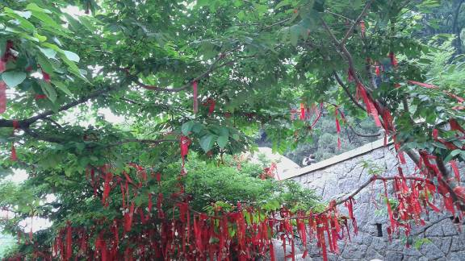

- Ten thousand Zhang tablet carved in 1748, 25 meters high and 13 meters wide. It is the folk name of the Emperor Qian Long’s poem and has been regarded as the print of the huge picture scroll of Mount Tai.

- Jade Emperor Temple
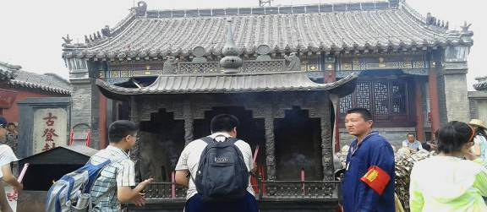
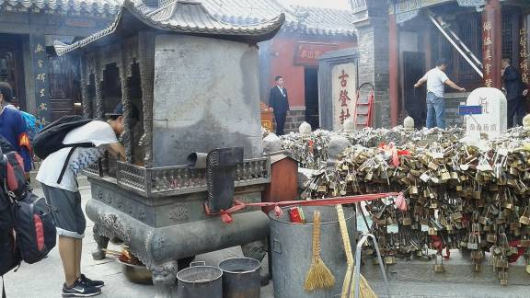
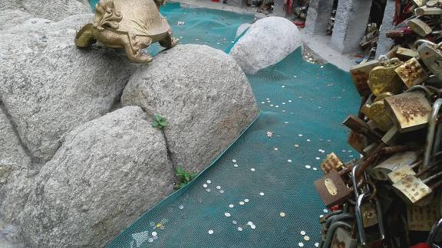
As the pictures shows, locks are use as the bridge in Paris. Couples come and put a lock to say: our love is lock so it will last forever. Some locks are also for family. Coins are thrown for wishes.

- Grand View Peak also named as CLIFF INSCRIPTION OF TANG DYNASTY. The text of the inscription with the name of INSCRIPTION COMMEMORATING MOUT TAISHAN is an account written by Emperor Tang Xuanzong in 726 A.D. To the east is the cliff inscription of Song Dynasty and to the west is the cliff inscription of Qing Dynasty.
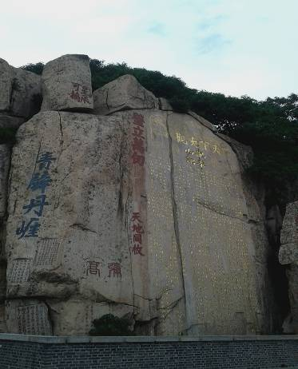

- The “Shopping Mall” visit
After the mountain climbing, school also took us to a mall not only for shopping but also to learn more about Shandong culture. In fact, we were lucky to saw and heard a man doing a little “show” for us.

Shandong Study Trip Summary
Visited Dates: 14th June to 16th June, 2015
Arranged by: International Education School (University of Economic & Business Hebei)
Participants: International Students and International Education School Staff
Vesting Places: Tai Shan Mountains and Qufu (Home town of Chinese Philosopher Confucius)
Purpose: To learn about the Chinese Culture and life of Confucius)
We departure on 14th June, 2015 around 01:00 pm from International Student Apartment – Hebei University of Economics and Business – Shijiazhuang (China) for the visiting of the famous Shandong Tia Shan mountains and great Chines scholar and think thinker Confucius home town Qufu. The participants of the trip were 20 students, Dean, Deputy Dean, 3 teachers and one staff member of the International Education School. On the way we stop in two points for refreshment, during that stay our honorable teachers told us some basic things of the Chinese culture.
We are arrived around 07:00 PM Tai'an city. Here we received by our travel guide, they already arranged dinner for our group in local restaurant. Here we served with different local Chinese delicious cosine foods. We went to bed sharply after the dinner because in next morning we have early visit of Tai shan mount.
15th June, 2015
Early morning around 08:00 Am a luxury bus pick our group from hotel for Tai Shan mount visit. In thirty minutes we reached to the point form we have to start climb for Tai Shan peak. Here our travel guide give some important instruction about the Tai Shan claiming tracks and step by step reaching to the top peak and important places in the way. Than we started the climbing together in the way we say many of warship places. After 1.5 hours we all reached to the point before 30 minutes to top of the peak there is bigger warship place and some restaurants for the tourists. The IES already arranged lunch for us in good restaurant, here we say for some minutes, than we served with different foods. After having lunch again we start to-wards top peak of the Tai Shan. Within 30 minutes we arrived here, our guide and teachers told us about the warship place history and Chinese beliefs regarding this place. Here we stay for 15 minutes. Then we started down ward. In 1 hour all we come down and together.
Mount Tai Shan Fast Facts:
- Mount Tai Shan is located in Shandong province, north of the city of Tai’an
- The tallest peack, jade Emporer Peak is reported to be 1,545 meters (5,069 ft) high.
- Mont Tai Shan is widely considered the most important of China;s sacred mountains.
- Has strong significance for those practicing the Taoist faith.
- There are more than 7,200 steps leading to the top of Tai shan.
- A number of temples and other significant monuments are located on the and around Tai Shan.
- The warship places fo China biggest scholar Confucius.
- Mount Tai is a UNESCO Heritage Site.
The visit of this mountain we completed around 16:30 pm than we visited a small museum where we saw the ancient age daily usage goods, agriculture equipment, and other things of other life of Shandong people. Here also enjoy from the local music in shape of famous Chinese phrases. We completed this short visit in one hour.
In evening around 07:00 PM we did our dinner in local Chinese restaurant and back to hotel for rest.
16th June, 2015
Early morning the bus pick us for the historical Qufu the place where the great think thinker Confucius born and spent his life. Qufu is about one hour form the Tai'an city. Here we visited the following places;
Confucius Family Mansion (Kong Fu).
East of the Temple of Confucius, is the Confucius Family Mansion (Kong Fu). Kong is the family surname of Confucius and his descendants. The mansion is where his first son and the first grandson lived. In scope, it is next only to the royal palaces of the Ming (1368-1644) and Qing (1644-1911) dynasties. Dynasties came and went but the First Family under Heaven has lasted the longest.
Covering 39 acres, the mansion grounds house 463 buildings such as halls, pavilions, and towers that are divided into three parts. The Eastern part is the family temple, the Western institute and the Central main buildings. The Central part is then divided into two sections with the front being the office and the family residence behind. The garden is located at the back of the residence.
Though less splendid than the Forbidden City, the Mansion boasts luxury furnishings, exquisite decorations, and precious cultural relics. These relics, some given by emperors, some presented by high ranking officials and celebrities, and some purchased at a high price, are the most valuable resource for research on ancient Chinese history and culture.
This family mansion is the largest of its kind in Chinese history. In 1994, the Mansion, the Cemetery and the Temple were listed as World Cultural Heritage buildings.

Confucius Cemetery (Kong Line)
Cemetery where the family and descendants of Confucianism are buried. It has the longest line of descendants in the world. Record has it that this cemetery has already lasted 2340 years. Confucius was buried there; the cemetery was about 1 qin (6.67hectares). It was continually expanded to over 3,000 mu (200 hectares) through constant l and grants by emperors of following dynasties. The walls here are 7 kilometers (4.35miles) long enclosing more than 10,000 tombs.
The sacred way that leads up to the cemetery is 1,266 meters (4,153 feet) and is lined with verdant pines and cedars. At the end of the road stands a wooden memorial archway - called the Most Sacred Cemetery (Zhi Sheng Lin), and is the gate to the Cemetery of Confucius.
The evolution of the Cemetery reflects the role of Confucianism through history. During his eventful life, the sage drifted from one place to another trying to persuade the authorities to adopt his philosophy, but with little success. It was during later dynasties that Confucianism gained popularity among the authorities. Therefore, before his tomb, a tombstone of the Master and the Most Sacred Wenxuan King was set up in 1443. To the east lies the tomb of his son, Kong Li, while to the south is the tomb of Kong Ji, his grandson. This configuration is called 'holding the son and hugging the grandson'; considered an ideal family pattern in China.
Here we spent around the 2 hours and we visit the above in details and our guide told us about each building, hall, office and their living.
In afternoon we started our journey to our home- Hebei. In late night we reached to our university.
In last I thanked to the International Education School, arranged such learning and joyful trip for us to learn about the Chinese culture and great thinker Confucius. We hope in future that they IES will arranged more such like trips for us to learn more about China.

HUEB TRIP’S REPORT
By Huo Sio Line Diana

In this document I would like to talk about the amazing experience we had this week. First of all I want to thank our school Hebei University Of Economics and Business for everything! For this nice trip who not only gave us the opportunity to visit one of the famous mountain in China, the confucius temple but also the most Important is to learn about the Chinese culture and history.
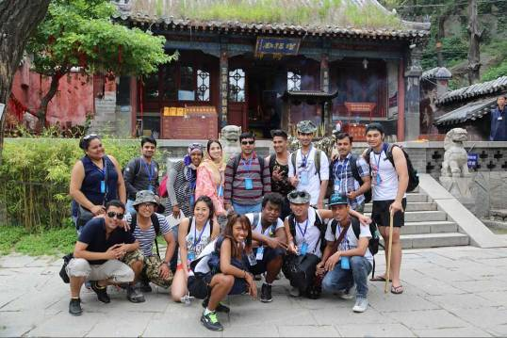
The tai mountain is a mountain of historical and cultural significance located in Tai’An city, in Shandong province. With a height of 1.545 meters, his majesty and splendour is incomparable. It’s one of the five great mountain in China and because of his history it is the most climbed mountain in China. In ancient times, the first thing for an emperor to do on ascending to the trone was to climb the taishan and pray heaven and earth or their ancestors. It was said that 72 emperors of different dynasties made pilgrimages here. In addition, many poets and literary also visited the mountain to gain inspiration. The tai mountain also played an important role in the development of Buddhism and Taoism. Tai shan is a cultural treasure house of temples, ruins, stone tablets and cliff face and rock inscriptions. We had the chance to see some of them during our tour, even if the climbing was not easy, that actually take us more than 3 hours to arrive on the top but the scenery is just beautiful. Since I came to China, I visited many kind of place but the taishan is one of my favourite so I suggest everyone to visit it.

Temple at the Top of mountain tai
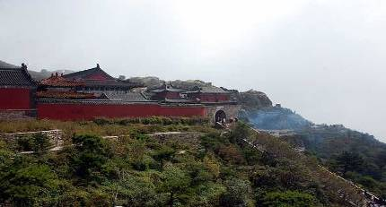

The final gate, the nan men
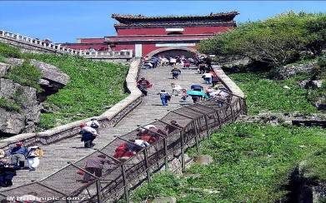
For the return, we took the cable. It was actually a big challenge for me because I’m scared of the hight. But I’m happy I did it and over came my fear. That will be a good memory for me.
After that we went to the mall shop, there a men did a little show for us. Even if I didn’t really understand the meaning of the song I really appreciated it, with his nice voice singing for us.

Now I’m going to talk about the second day. The visit of the Confucius hometown who is located in Qufu city in southwestern Shandong province. Qufu is a small city indeed but really nice, peaceful. Remind me the city where I live in my country. The city contains numerous historic palaces, temples and cemeteries and the three sites we visited are the temple of Confucius, the cemetery of Confucius and Confucius home. It is the hometown of the great chinese philosopher and educator Confucius. Now let’s go deeper with the Confucius.
The temple of Confucius is the second largest historical building complex in China after the forbidden city. It is a really interesting place, we can see for exemple the way the ancient Chinese pray, the old Chinese character on the gate, the statut in form of animal, even the trees have a story..

Historical plan of the Temple of Confucius

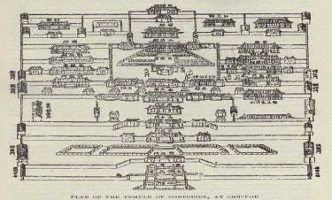

Dragon pillar in front of Dacheng Hall
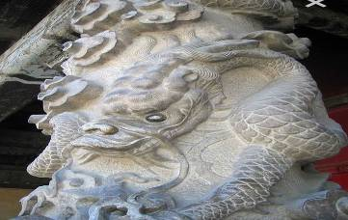

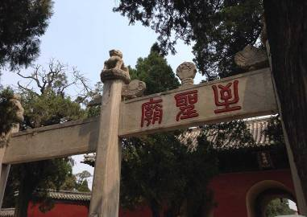
The cemetery of Confucius lies to the north of the town of Qufu. In this space, the tombs of more than 100.000 descendants of Confucius, who have been buried there over a period of about 2000 years.

Tomb of Confucius

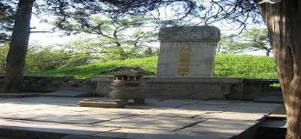

Now the last part is about the Confucius home, located to the east of the temple. Today, tha mansion comprises 152 buildings with 480 rooms and the layout of the mansion is traditionally Chinese.

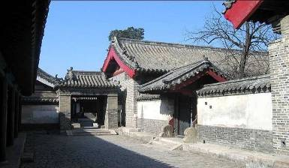

I really enjoyed the trip and I’m feeling happy and lucky to be part of it. I experimented a new horizon and discover new thing like climbing and now knows a little bit more about Chinese history and culture. For m, personally, everything was perfect start from the food, the place we stayed and our teacher did anything to make us feel comfortable. So thank you again to our school.

山东考察学习
马国志

听说学习汉语和文化的最好办法是学习历史。于是我们去山东省的泰山和曲阜市了。这一次的学习考察都是学校安排的，一共是三天的。第一天我们从学校出发，坐车五个小时我们到山东了。第一天我们什么都没活动，直接到了宾馆。我们的房间有三个床，我们三个兄弟一起住了。第二天我们早上七点起床了，然后准备去爬山了，在酒店前面买了一件雨衣。
泰山是中国的著名的山，国王他们都去泰山朝拜圣山，所以泰山在中国比较有名，它还是这个地区最高的山，所以泰山很重要。我们去爬山了。我们爬了两个多小时之后到了山顶。然后我们去看山庙，去朝拜山神。我们一边爬山一边看风景。下山了以后我感觉累了，我想回酒店了，但是我们还要去看山东的特色表演。在那边有很多特色店，所以我买了很多特色吃的东西，然后我们去吃饭了。回酒店之后我们兄弟几个又去逛街了。
这次学习最好一天、最重要的一天是去曲阜，曲阜就是孔子他的故乡。孔子是我的偶像我有机会去看他的故乡，心里有说不出的高兴。在曲阜我看到了他的庙，他的学校，他的墓等等。
通过这个学习旅游我有了机会更认识孔子，山东的特色和重要的事情，还有山东人们的生活和中国的圣山。我想感谢老师们给我机会去山东，陪我们去旅游和学习。这个学习旅游帮我理解中国文化和历史，我们学了很多中国的文化，很开心又学到很多知识。谢谢。

曲阜和泰山
那彬

好长时间以后学校有安排了一个教育旅游。这样的课外活动对学生们来说很重要。学生们多高高兴兴的参加了这次旅游。这次我们旅游的地方时一个很有名的地方，因为是孔子的故乡曲阜。

我们多知道孔子的故乡是山东省曲阜市。中国最有名的人是孔子。他出生于2500多年前，但他却一直活在中国认得心里因为孔子的儒家思想后来成了中华民族的主流文化。我得到机会到这样有天才人的出生地我很高兴了。哪里我们参观了三孔，孔庙，孔府和孔林。参观了这个地方以后我更 了解孔子。我从心里崇拜他我觉得他是一个神。这是一个世界文化遗产地所以来这里参观的人比较多。

除了曲阜我们也去过泰山，1545米高山，中国很有名的山之一。这是一个世界自然遗产。很久很久以前这个地方就是一个大海。我么多爬泰山不太容易但是跟老师们一起慢慢爬没有累的感觉。我们终于到山顶，我有到天堂一样的感觉。丛泰山上看别的山都变矮了。哪里的环境特别美。

三天中我有机会参观文化遗产和自然遗产我很高兴。学校安排了这么的旅游我就要感谢他们也建议经常安排这样的活动。
谢谢

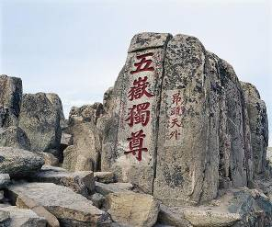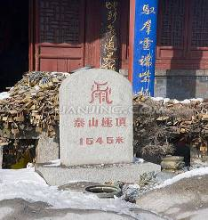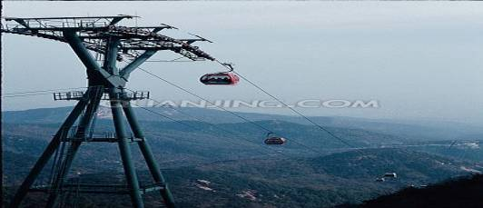

2.3项目总结

“孔子故里”文化考察结项总结

- 项目基本情况
项目名称：“孔子故里”文化考察及“我眼中的中国”摄影、写作比赛
项目性质：河北经贸大学国际教育学院2015年来华留学生教学活动项目
项目主持人：刘昕远
立项时间：2015年4月
项目实施时间：2015年6月

- 项目实施过程
- 文化考察项目
在国际教育学院的领导和支持下，2015年6月14日至6月16日，“孔子故里”文化考察项目实施。此次文化考察由国际教育学院成健院长、张希颖副院长带队，来自巴基斯坦、尼泊尔、马达加斯加、科特迪瓦等国的19名留学生及项目主持人刘昕远等4名教师参加了本次文化考察。
2015年6月14日，项目考察组师生乘大巴车抵达山东。6月15日，师生考察攀登泰山，一路上老师给大家讲解泰山石刻和独特的泰山文化，讲解泰山在中国文化中的独特地位，学生们领略感悟了“五岳之尊”的泰山文化。6月16日，项目考察组抵达“孔子故里”山东曲阜，参观考察孔庙、孔府和孔林，了解孔子和儒家文化，还欣赏了具有地方特色的“山东快书”。在考察过程中，老师们为大家讲解了孔子及其儒家文化，把文化考察活动和课堂教学紧密结合起来。
- 摄影、写作项目
为了进一步巩固和提升留学生文化考察学习的效果，在考察活动之初，老师就给同学们布置了任务，那就是认真学习、观察和思考，用镜头和纸笔记录本次考察活动的体会和感受，要求每个参与考察的同学交三张照片和一篇文章。考察归来后，结合本次文化考察，我们开展了“我眼中的中国”留学生摄影比赛、写作比赛，同学们积极参与，精选上交了30张文化考察的照片和15篇文章，活动圆满结束。

- 项目成果和意义
  - 增进了留学生对中国传统文化和现代社会的了解。
留学生读泰山石刻，听泰山故事，参观孔庙、孔府和孔林，欣赏“山东快书”，一路上领略中国社会风土人情，惊叹中国社会的高速发展，增加了对中国传统文化、中国现代文化和中国风土人情、历史地理的认识与了解，培养了知华、爱华情怀。
  - 激发了他们深层次了解中国社会、学习中华文化的兴趣。
中国博大精深的历史文化、各具特色的风土人情，高速发展的社会经济，开阔了留学生的视野，也激发了他们深层次了解和学习中国社会和中华文化的兴趣。
  - 丰富了专业知识，提高了汉语技能。
参与考察的很多留学生是在中国学习国际贸易等专业的，通过考察学习，他们增加了对中国社会的了解，也丰富了专业知识，提高了专业技能。此外，在学习考察过程中，留学生们试着用汉语和中国人交流，提高了他们的汉语技能，也进一步增强了他们学习汉语的热情。
  - 增强了留学生的团队精神。
相对于中国学生来说，外国留学生比较自由散漫，时间观念不强。这次文化考察是一次团队出行，我们时刻强调时间观念和团队意识，同学们基本上做到了守时、守纪律，增强了时间观念和团队精神。
  - 增进了师生之间、留学生之间的情感交流。
考察学习也为师生之间、留学生之间提供了互相了解和学习的机会，一路上大家互帮互助，共同学习，增进了彼此之间的感情，对以后的学习生活具有积极的促进作用。

- 反思和建议
  - 扩大文化考察的领域和范围
此次文化考察的目的地是“孔子故里”山东曲阜，重点是让学生了解孔子和儒家文化，侧重于中国传统文化。除了中国传统文化，外国学生也应该了解中国现代社会和现代文化，所以，今后留学生的文化考察范围可以更广泛，可以走得更远。
  - 分专业、分国家进行文化考察
留学生所学专业不同，来自的国家不同，他们需要的文化考察也应有所差异，所以今后的文化考察可以根据学生的专业不同、国籍不同而有针对性地进行。
  - 加强文化考察前的教育
文化考察是课堂教学的延伸，在进行文化考察前，要对学生进行必要的教育，比如介绍考察的目的、意义，给学生讲解相关的专业知识，明确对学生的要求，从而达到良好的学习考察效果。

