A summary report on the China University Business Challenge – 2016
- Introduction
Name of the Competition: China University Business Challenge
Date: 2016-05-26 to 2016-05-30 Place: Ningbo International Exhibition Centre, Ningbo
Participants School: IES, Hebei University of Economics and Business

- Exhibiting Company
Hebei Zhida Import and Export Company Limited, is located in Shijiazhuang, North Youyi Street,Hebei, China. The company is a famous international textile trading company. It has its own factory with skilled labour force able to compete in the competitive market with the high quality product and according to costumer demand. They are specialized in manufacturing outdoor adventure garments wears for all seasons. The company uses better fabric and latest clothing material for the production and offer garments from fleece, pile, coating and soft-shell, shell jackets, pants and suits with the finest materials and varieties colours. Design and innovative new product is according to the demand of customers, market and fashion. The company can produce the things according to the customer’s need and design. Company can manufactures the clothing with customers’ own LOGOs.
2.1 Products of the company
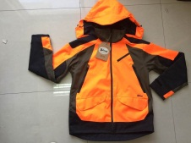 | 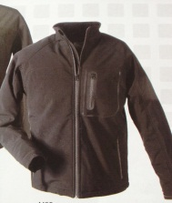 | 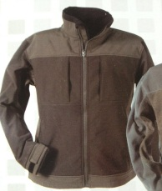 | 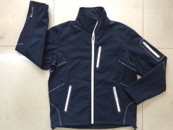
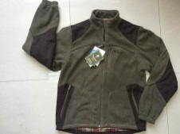 | 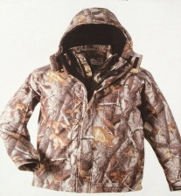 | 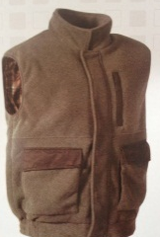 | 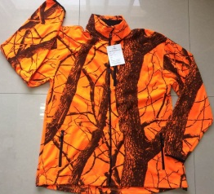
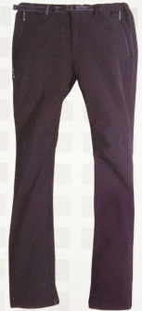 | 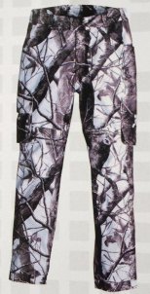 | 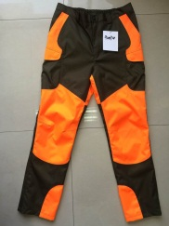 | 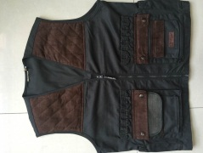
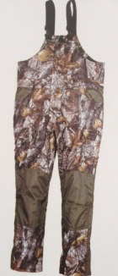 | 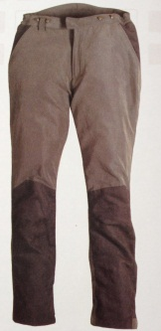 | 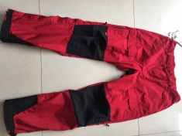 | 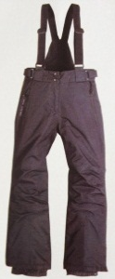

- Preparation of the Exhibition:
To participate in this competition, IES, HUEB formed a team of six member leaded by Bikash Thapa. Each member was qualified and well known about the trade and business since they were Masters and Bachelors Students of international trade. They participated as:
Exhibition Manager- 1 (Valentine)
Sales Executives-2 (Bikash, Ali)
Sales assistant -2 (Mihi, Elsa)
Exhibition Assistsant-1 (Mona Liu)
May 10: Visited Hebei Zhida and collected necessary information and product samples
May 12: Submitted a brief exhibition planning and report
May 12-20: Held several discussions and meetings to plan about the exhibition, create different ideas and design to decorate the exhibition booth, finalized the idea and start collecting necessary materials.
May 22: Visualized the Video for New product conference
May 24: Edited the video according needed.
May 25: Gathered all the necessary things and objects for the exhibition

- Exhibition Time
May 26: Arrived Hotel at Ningbo and Registered for the exhibition, collected information materials, tool kit and handed them the video for the new product conference.

May 27: Went to the exhibition hall and start decorating the exhibition booth according to the innovative idea. The booth was be simple open designed where customer can get inside and observes the displayed product. There were enough space for the customers dealing and communicating. Wallpapers and pictures are used to design and create the moods of adventures activities that make customer a part of them. The Logo and Company name was placed in the centre of the wall.

May 28: Exhibition started on this day we did following things
- Analyzing the Customers behavior, grab chance to get closer and start communication
- Provided enough information about the company and the product.
- Answered all the queries of the customers with adequate information
- A leaflets and handouts were distributed.
- A small gift as a souvenir was provided.
- Negotiation was accomplished in very warm environment. Guests were cordially welcomed and requested to have a seat. Started communicate from personal introduction. Guests were informed about the company and the products and quality. The offers were made and discussed on counter offers. All the techniques and business plans were used for persuading. We were able to establish a good relation but could not reach to the final contract level.
May 29: Submitted exhibition report and Visited to the exhibition place, accomplished the exhibition and cleaned the booth.
May 30: Visited the announcement hall, collected our position award and back to the school.
- Exhibition Analysis:
After the exhibition I have realized the following points:
- Decoration of the booth should be effective and have to add more attractive features.
- Innovative idea with a lots of activities should be done for the new product conference
- Work division should be more specific and efficient with in the team members.
- Time should be managed while decorating
- Proper communication should be established with in the team.
- The negotiation is smooth and specific with professional knowledge.
- Should be more professional in other exhibition and events.
- Some other booths are more attractive and had added more features.
- The promotion technique and display of the goods are very effective.
- Competitors are Well prepared and had specific work division than us.

- Suggestion:
Here, I would like to make some suggestion for the school and organizer:
  - School
- If possible, find a good and reputed company and make a contract with them who can sponsor whole costs of these kinds of event so that school costs could me minimised.
- Provide all the related information in the time in order to have plenty of time space for the preparation.
- If possible let them know the allocated budget for the project so that they can adjust and decide the things before buying.

  - Organizer:
- Publication hall and exhibition hall should be separated in different places to reduce the noise level.
- The visitor’s way to visit booth should be wider in order to reduce the crowd.
- Because of the weather and the crowd, the place was very hot, so effective steps should be carried out.
- Negotiation part should be more transparent and effective to judge the professional skill of the participants.

- Conclusion:
Though the preparation time is very short and limited, we work hard for the exhibition and secured the second position. Still, there were some weaknesses that I had mentioned above. Hope those weaknesses would not be repeated again. Once again we are thankful to IES, HUEB for this wonderful opportunity for the participation where we can use all our academic knowledge in practise in order to face the real challenges. We cordially appreciate the organizer for these kinds competition.

